VACATION BIBLE SCHOOL
Sponsored by Faith UMC
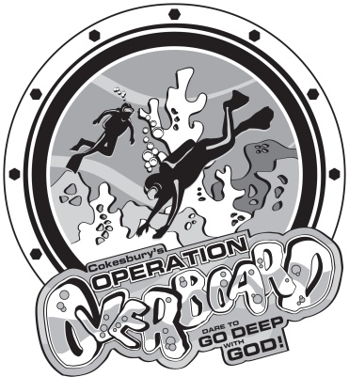
Where? Faith UMC, 1290 Fruitville Pike, Lititz
(Manheim Twp: Corner of Fruitville Pk & Koser Rd)
When? July 30th to August 3rd
What time? 6:00 pm to 8:00 pm
Ages? 4 to 11 years old
To register or to find out more about Operation Overboard, call the church office at
717-560-0321 or visit our VBS website at http://2018.cokesburyvbs.com/faithumclititz. You may also find a link, download forms or find out more about our church at www.FaithUMC.us.

“Faith is the reality of what we hope for, the proof of what we don’t see.”
Hebrews 11:1 CEB

VACATION BIBLE SCHOOL
Sponsored by Faith UMC
Where? Faith UMC, 1290 Fruitville Pike, Lititz
(Manheim Twp: Corner of Fruitville Pk & Koser Rd)
When? July 30th to August 3rd
What time? 6:00 pm to 8:00 pm
Ages? 4 to 11 years old
To register or to find out more about Operation Overboard, call the church office at
717-560-0321 or visit our VBS website at http://2018.cokesburyvbs.com/faithumclititz. You may also find a link, download forms or find out more about our church at www.FaithUMC.us.

“Faith is the reality of what we hope for, the proof of what we don’t see.”
Hebrews 11:1 CEB

Overboard: Dare To Go Deep With God! Your children will become divers-in-training at Operation Overboard as we plunge into God's Word and discover stories of deep faith.
After a high-energy opening at Ocho's Cove, the divers make their way to the Underwater Passage.
Interactive Bible lessons reveal five ocean insights for living as a follower of God, and your divers will
discover Sea Scripture memory verses that will boost their faith long after VBS.
The children will expand on what they've discovered by participating in a variety of activities:
making their own art projects at Aquatic Arts, singing new music at the Choral Reef,
exploring science activities at Exploration Station, participating in recreational activities at
High Tide Hangout, and enjoying tasty snacks at the Diver's Diner.
Dive right in! Join us at Faith United Methodist Church, 1290 Fruitville Pike, Lititz, PA,
17543 (Manheim Township: corner of Fruitville Pike and Koser Road) on July 30th to
August 3rd from 6:00 pm to 8:00 pm. Everyone is invited back to our 10:30 am
worship service on Sunday, August 5th when the children will share what they
have learned. Please stay for a family picnic after the service.
To register or to find out more about Operation Overboard,
call the church office at 717-560-0321 or visit our VBS
website at http://2018.cokesburyvbs.com/faithumclititz.
You may also find a link, download forms or find out
more about our church at www.FaithUMC.us.
Sincerely,
Carol Kennedy, VBS Director

Overboard: Dare To Go Deep With God! Your children will become divers-in-training at Operation Overboard as we plunge into God's Word and discover stories of deep faith.
After a high-energy opening at Ocho's Cove, the divers make their way to the Underwater Passage.
Interactive Bible lessons reveal five ocean insights for living as a follower of God, and your divers will
discover Sea Scripture memory verses that will boost their faith long after VBS.
The children will expand on what they've discovered by participating in a variety of activities:
making their own art projects at Aquatic Arts, singing new music at the Choral Reef,
exploring science activities at Exploration Station, participating in recreational activities at
High Tide Hangout, and enjoying tasty snacks at the Diver's Diner.
Dive right in! Join us at Faith United Methodist Church, 1290 Fruitville Pike, Lititz, PA,
17543 (Manheim Township: corner of Fruitville Pike and Koser Road) on July 30th to
August 3rd from 6:00 pm to 8:00 pm. Everyone is invited back to our 10:30 am
worship service on Sunday, August 5th when the children will share what they
have learned. Please stay for a family picnic after the service.
To register or to find out more about Operation Overboard,
call the church office at 717-560-0321 or visit our VBS
website at http://2018.cokesburyvbs.com/faithumclititz.
You may also find a link, download forms or find out
more about our church at www.FaithUMC.us.
Sincerely,
Carol Kennedy, VBS Director

